Branden Soo
ACCT 371
02/20/2026
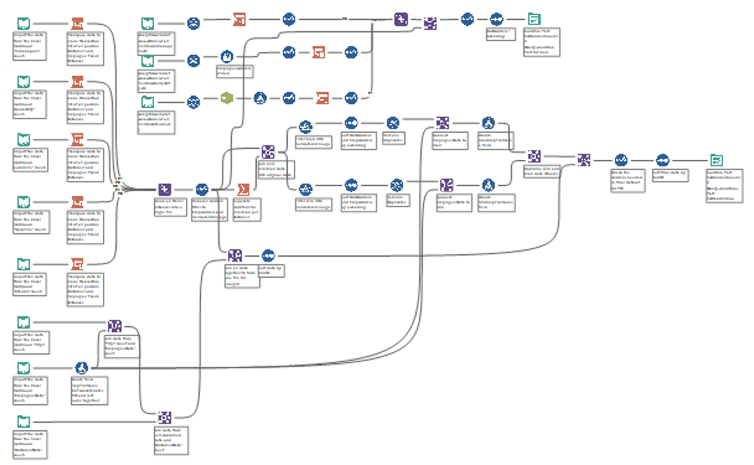
PART 3 ALTERYX
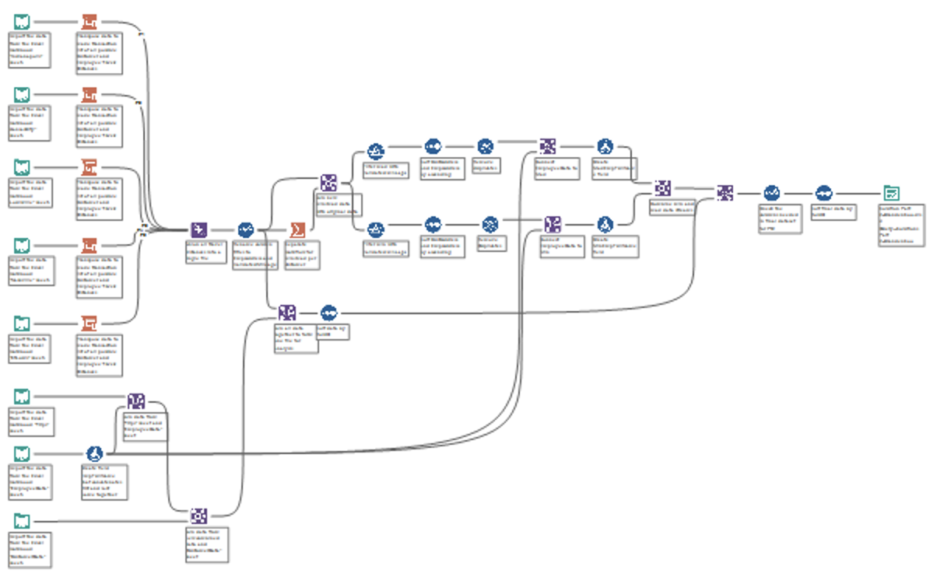
PART 2 ALTERYX
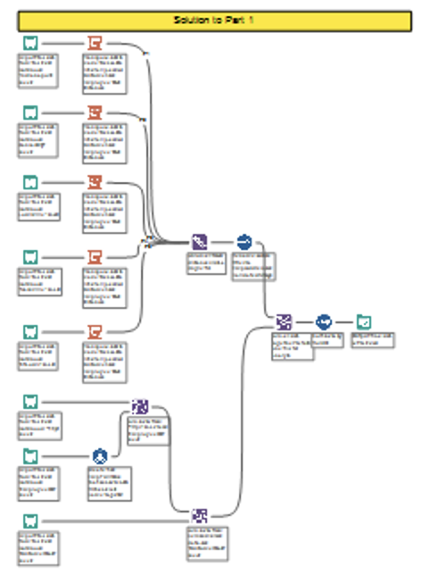
PART 1 ALTERYX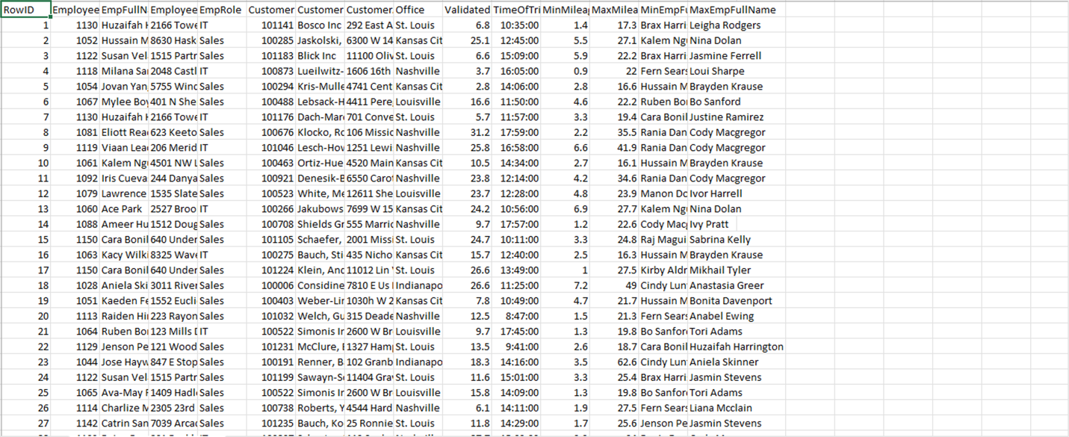
PART 2 EXCEL
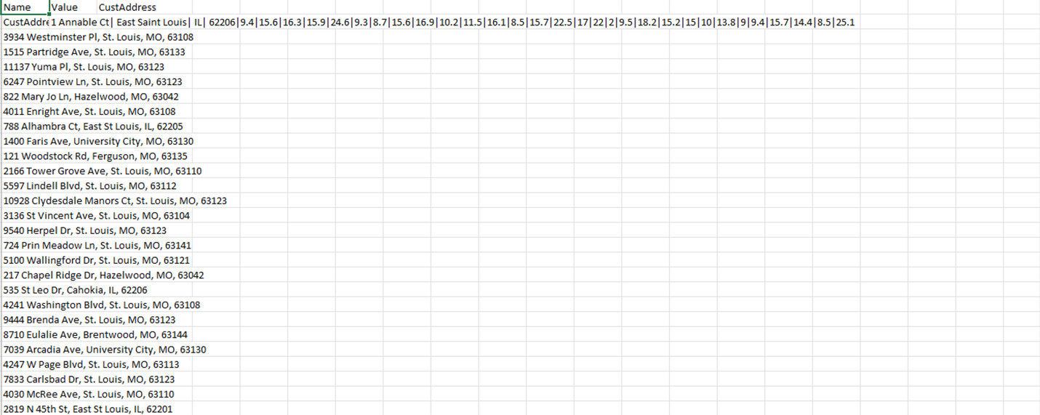
PART 3 EXCEL
My Logic for incomplete part 3:
For the Indianapolis csv, I’d use Input Data to insert the csv file, unique to remove the duplicated customer rows, and . For the KansasCity csv, I’d use Input Data and the Multi-Row Formula to combine the street row with the city, state, and zip, then Filter to drop the extra partial rows, and Select to rename the fixed field back to EmployeeAddress so the join matches Part 2 data. For the StLouis csv, I’d use Input Data again, Text To Columns to split the customer address, then a Formula tool to recombine the address into one clean CustomerAddress field, and a Select tool to keep only the corrected address columns, so the data can union cleanly with the other cities and produce the same Part 2 output.

